Please Answer the Following Questions:

1. Which factors are essential for supporting life as we know it? (Select the 3 BEST answers):
- Solar radiation
- A liquid medium
- Raw materials in the form of atoms
- Raw materials in the form of ions
- A solid medium
- A gas medium
- An energy source
- A living food source
- Warm or hot temperatures
- Oxygen

2. Define adaptations. Adaptations:
- take time to develop over an organism’s lifetime.
- allow organisms to survive in extreme environments
- typically enable organisms to take on complex shapes.
- typically enable organisms to take on simple shapes.

3. What evidence on Mars provides clues that life may have existed there? Use your understanding of the requirements for life to guide you.

- Sand dunes
- Ancient river beds
- Dry ice caps at the poles
- Oxygen in the atmosphere

4. An environment such as Yellowstone has extremely hot water pools. Some of these pools are also acidic. Which of the following adaptations would best help an organism survive in this type of environment?

- Ability to rebuild its genome after exposure to high levels of radiation
- Ion pumps that maintain pH inside the cell
- Ability to survive in low levels of oxygen
- Antifreeze proteins that keep its blood from freezing

(over)

5. Maria sets up an experiment to test extremophiles (organisms that live in extreme environments). She puts 10 brine shrimp cysts in each of three petri dishes. She puts 20 ml of 0% salinity solution in dish 1. She puts 20 ml of 3% salinity solution in dish 2. She puts 20 ml of 15% salinity solution in dish 3. She inspects the dishes at 1 day, 2 days, and 7 days to count how many hatch. What question is Maria testing (select the BEST answer)?

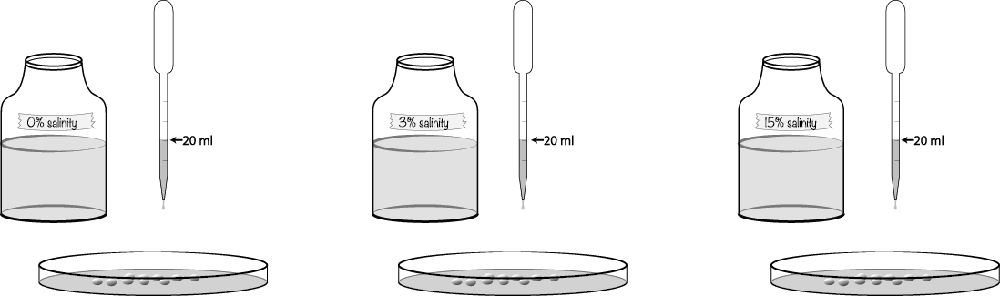

- Which abiotic factors keep brine shrimp cysts from hatching?
- How much time does it take brine shrimp cysts to hatch?
- In which salinity solution have brine shrimp adapted to survive?
- Will 20 ml of saline solution provide the best hatching conditions?

6. In which domain(s) of life are extremophiles (organisms that live in extreme environments) found?
- Archaea only
- Bacteria and archaea
- Bacteria and eukaryotes
- Bacteria, archaea, and eukaryotes

7. Why are tectonic plates an essential condition for supporting life?

- They recycle minerals and available nutrients.
- They change the composition of the layers of the lithosphere.
- They create earthquakes.
- They cause spreading of sea floor.

